To: NAST Members
From: Catherine Seat, Communications Director

Introduction
In this toolkit you will find several ways to promote 529 Day in your state. We have organized graphics, created sample tweets, and drafted both an op-ed for your local paper as well as a press release. Please use any/all of the resources!
If you have any questions or would like some additional support, please reach out to Catherine at Catherine@statetreasurers.org.

Sample Graphics
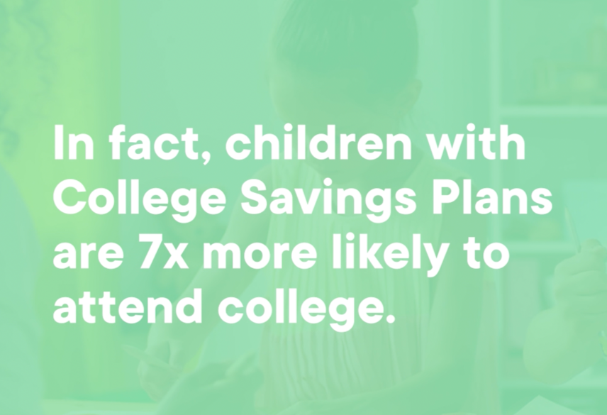

Sample Social Media Posts
Hashtags: #529Day #529ForTheirFuture #CollegeSavings
Relevant Accounts: @StateTreasurers @529forCollege
Here is a 529 #FunFact: There is over $480 billion saved in 529 accounts across the country in over 15.7 million accounts. #529Day #529ForTheirFuture
Here is another 529 #FunFact: The average account balance in a 529 account is $30,652. #529Day #CollegeSavings
Think you know everything about 529 accounts? Take this quiz to test your knowledge: https://bit.ly/31dtwsd #529Day
College can be expensive. Do you know how much to plan for? Check out this college cost calculator to see if you are on track: https://bit.ly/3fbShx1 #SaveForTheirFuture #529Day
Celebrate #529Day by checking out your options to open a 529 account: https://bit.ly/3d3vLUv
Sample Press Release
May XX, 2022 (City, State) – Today, the State of XX and the {INSERT PROGRAM NAME HERE} recognize the importance of saving in a 529 account. As of December 2021, over $480.3 billion dollars are currently being invested for education around the country in 15.7 million individual accounts.
{INSERT QUOTE FROM PROGRAM ADMINISTOR OR TREASURER}
Events are happening all over the country to celebrate 529 Day. This is a specific day every year dedicated to showcasing the value of investing in a 529 program. Many are offering incentives to those with accounts, virtual and in-person events as well as social media activities.
{INSERT SPECIFIC LOCAL PLANS TO RECOGNIZE 529 DAY}
529 plans make it easy and affordable to plan ahead for the cost of higher education at colleges & universities, technical & community colleges, trade schools and many other post-secondary education programs. Investing in a 529 account not only helps individuals budget, but it also provides tax advantages to the account owner. While state tax incentives vary, federally, money grows in a 529 account tax deferred and then it can be withdrawn tax free if used for qualified expenses. Those expenses range from college tuition, books, computers and more.
The College Savings Plan Network and Invite Education teamed up to make it even easier to find and compare 529 plans across the country. To check out the new tools, click here for search and comparison or here to find your state plan. If you would like to learn more about 529s, please visit: collegesavings.org or if you would like to learn more about {INSERT PROGRAM NAME HERE} visit {WEBSITE LINK}.
###

Sample Op-Ed
While everyone in the country is celebrating Memorial Day weekend and the start of summer, I am here to suggest that the 29th of May should also be a day that is acknowledged and celebrated this weekend. Why the 29th? Well, it is section 529 of the internal revenue code that allows for tax advantaged education saving programs. So, May 29th has been renowned in the industry as a day to encourage saving for education and preparing for academic success.
The timing could not be any better as students are getting out of school, many graduating and looking forward to the promise of higher education ahead. Paying for that education should not be a concern or a hinderance but, unfortunately, many times money is the largest hinderance to further education. The cost of a four-year public college has increased 225% over the last 30 years, according to the College Board. How can families prepare for an ever-increasing cost of education?
Thankfully, {INSERT PROGRAM NAME} here in {INSERT STATE NAME} has been working diligently to provide a tax-advantaged 529 program available to {INSERT RESIDENT NICKNAME i.e. HOOSIERS}. In fact, across the country over 15.7 million accounts have been opened be individuals and they have collectively saved over $480.3 billion. {INSERT PROGRAM SPECIFIC STATS LIKE THE AVERAGE AGE OF A BENEFICIARY OR AVERAGE ACCOUNT BALANCE} While saving for the entire cost of education may be daunting, every dollar saved is one more dollar that someone would not need to borrow and that is a win.
{INSERT PROGRAM NAME} accounts can be used at any institution that accepted FASSA funding so a four-year private university, a two-year community college or even apprenticeship programs. These educational opportunities don’t even need to be located in {STATE NAME} to be used – they can be used in any state! One of the biggest concerns is “What if my child chooses not to use their 529 funds?” Luckily, there are several provisions for that money to still be put to use. An account owner can transfer the money to another beneficiary in the same family or it can be indefinitely left in the account until a need arises. Worst case solution, the money can be withdrawn with a small penalty for the earnings in the account during the time it was active.
Want to participate? Leading up to the 29th of May, {INSERT PROGRAM NAME} has the opportunity for {INSERT LOCAL 529 DAY PLANS}
For all the Star Wars fans, let’s make the 29th of May at least as popular as the 4th of May.

Proclamation
Proclaiming the month of September as
“College Savings Month”
Or
Proclaiming May 29 as “529 Day”
Whereas, As the State of [state] is committed to competing in the global economy, our citizens must recognize the challenge ahead and provide their children with the education and skills that will enable them to compete successfully; and
Whereas, The rising cost of higher education has out-paced inflation and the growth in family income, all of which pose a serious threat to the ability of our citizens to ensure their children’s access to post-secondary education; and,

Whereas, The amount of student loan debt continues to rise to historic levels, leaving college graduates with the ever-increasing burden of paying for their college education long after they have completed their education; and,
Whereas, It is in the State’s interest that access to post-secondary education for our children be maintained and that encouraging parents to save for their children’s education promotes that public purpose; and,
Whereas, It is in the best interest of our State's employers to ensure a well-educated workforce; and

Whereas, Government, at both the federal and state levels, needs to encourage savings versus consumption and assisting rather than hindering parents, grandparents, friends, and businesses, as they seek to support the education of children, grandchildren, and others in need of help to meet their higher education goals; and,
Whereas, The State of [state] provides a college savings plan as a Section 529 Qualified State Tuition and Savings Plans (QSTP) through duly enacted laws passed by the state’s legislature, including state tax incentives as [deductions and/or exemptions] for their citizens as a recognition of the value of higher education opportunity];
Now, Therefore, I, [Governor], Governor of the State of [state], do hereby proclaim the month of September, 20XX, as “College Savings Month.” (or May 29, 20XX, as 529 Day). In doing so, I urge families and employers throughout the State to recognize the benefit of attaining a higher education and urge the citizens of [state] to begin saving for their children’s education.

IN WITNESS WHEREOF, I have hereunto set my hand this [first/other day of the month] day of September, in the year of our Lord two thousand XX.
___________________________ [Insert City/State or Other Official Seal]
Signature

Resources
529 Plan Policy Brief
How States are Celebrating 529 Day
529 Quiz
CSPN Blog
State by State Comparison Tool
Find My State’s Plan

