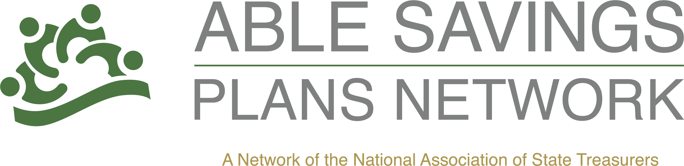

National ABLE Savings Day Communications Tool Kit

Use this toolkit to promote National ABLE Savings Day on August 14, 2026. Update the placeholders below with your state's program information, current national statistics, and links before publishing.
Social media accounts to monitor:
ABLE today: @abletodayorg

Social Media Posts:

Did you know that August 14th is National ABLE Savings Day? Learn more about the plans available all over the country here. #ABLESavingsDay

Think you know everything about ABLE Savings Plans? Debunk some of the myths here. #ABLESavingsDay

There are 246,000 ABLE accounts open nationwide. Are you one of them? Learn more about {SPECIFIC PROGRAM} by clicking here {INSERT LINK}. #ABLESavingsDay

Thanks to ABLE Savings Programs, many Americans living with disabilities have more independence than ever. Learn more here. #ABLESavingsDay

Check out this video to hear the personal impact ABLE Savings Plans are having all across the country. #ABLESavingsDay
Sample Press Release:

Celebrating National ABLE Savings Day

{CITY, STATE} (August 11, 2026) – August 14th will mark the third National ABLE Savings Day where those involved in ABLE Savings Plans programs across the country highlight the value and importance these plans bring to those living with disabilities.

The Stephen Beck, Jr. Achieving a Better Life Experience Act (ABLE Act) became law on December 19, 2014. The ABLE Act creates a new option for qualified individuals living with disabilities and their families to save for the future, while protecting eligibility for public benefits.

ABLE plans can change the way individuals with disabilities and their families participate in the community, build financial wellness and plan for the future by empowering them to save and invest for the added expenses that come with having a disability while protecting eligibility for federal means-tested benefits like SSI and Medicaid.

ABLE accounts foster person-centered independence, build self-reliance, encourage employment and improve quality of life. Contributions to ABLE accounts can come from earnings, family, friends and other sources. Earnings on ABLE accounts are tax-deferred, and withdrawals are tax-free as long as they are used for qualified disability-related expenses.

{INSERT INFORMATION ABOUT SPECIFIC PLAN}

For more information about ABLE Savings Plans, visit the National Association of State Treasurers here. To learn more about {SPECIFIC PROGRAM}, click here to visit their website.

###
Sample Media Pitch
Subject: Local Experts Available for National ABLE Savings Day Stories
Hello,
August 14 is National ABLE Savings Day, a nationwide effort to raise awareness of ABLE savings accounts and the financial independence they provide for individuals living with disabilities.
{STATE PROGRAM} is available to discuss how ABLE accounts help eligible individuals save and invest for qualified disability expenses while protecting eligibility for certain public benefits. We can also provide:
- State-specific enrollment and participation information
- Interviews with program representatives
- Account owner or family success stories (when available)
- Background on recent developments and the growing impact of ABLE programs
National ABLE Savings Day is an opportunity to highlight practical financial tools that are helping individuals with disabilities achieve greater independence, prepare for future expenses, and pursue their personal and professional goals.
If you're planning coverage of disability issues, personal finance, back-to-school resources, or community initiatives, we'd be happy to connect you with a spokesperson.
For interviews or additional information, please contact:
{INSERT INFO}

Sample Op-Ed:

Imagine not being able to save more than $2,000 in your name, at any one given time. Imagine not being able to save for home ownership or your first car. Over 61 million people in the United States may be dealing with this issue daily. Americans living with disabilities, who seek federal medical benefits, are limited to the amount of cash they are allowed to have at one time. This not only can cause poor spending choices but also restricts the ability of the individual to fulfill their American dream.

Thankfully, back in 2014, Congress passed a piece of legislation called The Stephen Beck, Jr. Achieving a Better Life Experience Act (ABLE Act) and it was signed into law by President Obama. These new state-run savings accounts, modeled after 529 savings plans, allow individuals to save and invest money without harming their ability to receive public benefits.

Many state programs have been in existence for over 7 years and are beginning to see the life changing value of these ABLE savings plans. {INSERT LOCAL STORY FROM YOUR PLAN}

Currently, according to the National Association of State Treasurers, there are 46 states and DC who have launched ABLE programs and 246,000 accounts have been opened nationwide. In those accounts, $3.2 billion has been invested in ABLE savings plans and the average account balance is $13,200. That is more than six times what people living with disabilities were able to save before these plans came into existence. They are already changing lives!

On August 14th, ABLE plans nationwide are celebrating the third National ABLE Savings Day to highlight the significance of these programs to Americans living with disabilities. During the entire month of August, {INSERT PLAN} has been preparing and planning {INSERT EVENTS/PROMOTIONS}.

During the month of August, and every other month of the year, {INSERT PLAN\AUTHOR NAME} strives to bring this valuable resource to as many {STATE INDIVIDUAL NAME ie. Hoosier} as possible. ABLE plans bring much needed financial independence and it’s our responsibility to get the word out!

Sample Email to Account Owners:
Subject: Celebrate National ABLE Savings Day with {PROGRAM NAME}
Dear {First Name},
August 14 is National ABLE Savings Day, and we're proud to celebrate the opportunities ABLE accounts provide to individuals with disabilities and their families.
Thank you for being part of the {PROGRAM NAME} community. By opening an ABLE account, you've taken an important step toward greater financial independence and long-term security.
National ABLE Savings Day is also a great reminder to make the most of your account. Consider taking a few minutes to:
- Make a contribution to your ABLE account.
- Invite family and friends to contribute toward your savings goals.
- Review your investment selections and beneficiaries.
- Update your contact information if anything has changed.
- Share information about ABLE accounts with someone who may benefit from learning about the program.
Every contribution—large or small—helps build financial security and supports the goals that matter most to you.
To learn more about your account or make a contribution today, visit {PROGRAM WEBSITE}.
Thank you for allowing {PROGRAM NAME} to be part of your financial journey. We look forward to continuing to support you and celebrating National ABLE Savings Day together.
Sincerely,
{Program Director Name}
{Program Name}

Resources:

NAST - ABLE Advocacy

NAST - ABLE Plans Across the Country

NAST - National ABLE Plan Data

ABLE today - ABLE today

