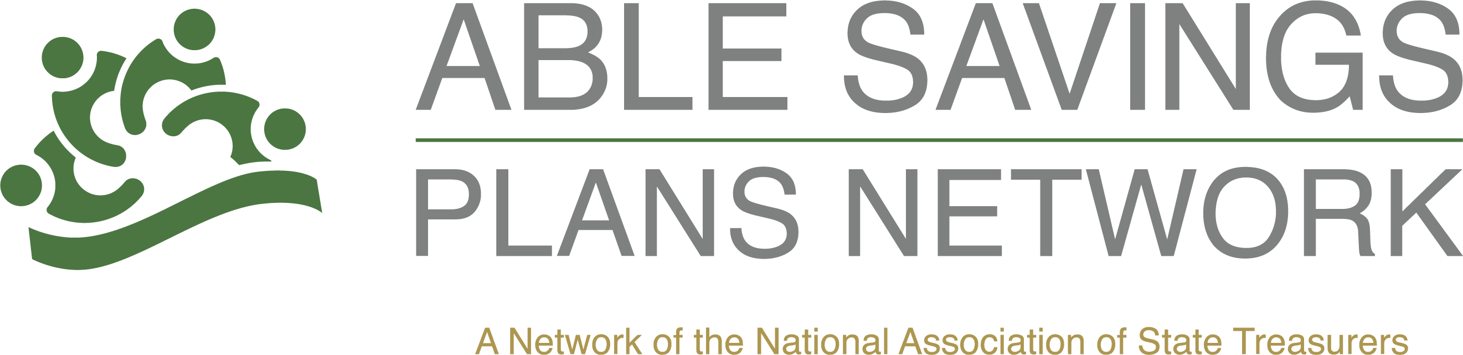

National ABLE Savings Day Communications Tool Kit

Sample Email to Account Owners:
Subject: Celebrate National ABLE Savings Day with {PROGRAM NAME}
Dear {First Name},
August 14 is National ABLE Savings Day, and we're proud to celebrate the opportunities ABLE accounts provide to individuals with disabilities and their families.
Thank you for being part of the {PROGRAM NAME} community. By opening an ABLE account, you've taken an important step toward greater financial independence and long-term security.
National ABLE Savings Day is also a great reminder to make the most of your account. Consider taking a few minutes to:
- Make a contribution to your ABLE account.
- Invite family and friends to contribute toward your savings goals.
- Review your investment selections and beneficiaries.
- Update your contact information if anything has changed.
- Share information about ABLE accounts with someone who may benefit from learning about the program.
Every contribution—large or small—helps build financial security and supports the goals that matter most to you.
To learn more about your account or make a contribution today, visit {PROGRAM WEBSITE}.
Thank you for allowing {PROGRAM NAME} to be part of your financial journey. We look forward to continuing to support you and celebrating National ABLE Savings Day together.
Sincerely,
{Program Director Name}
{Program Name}

