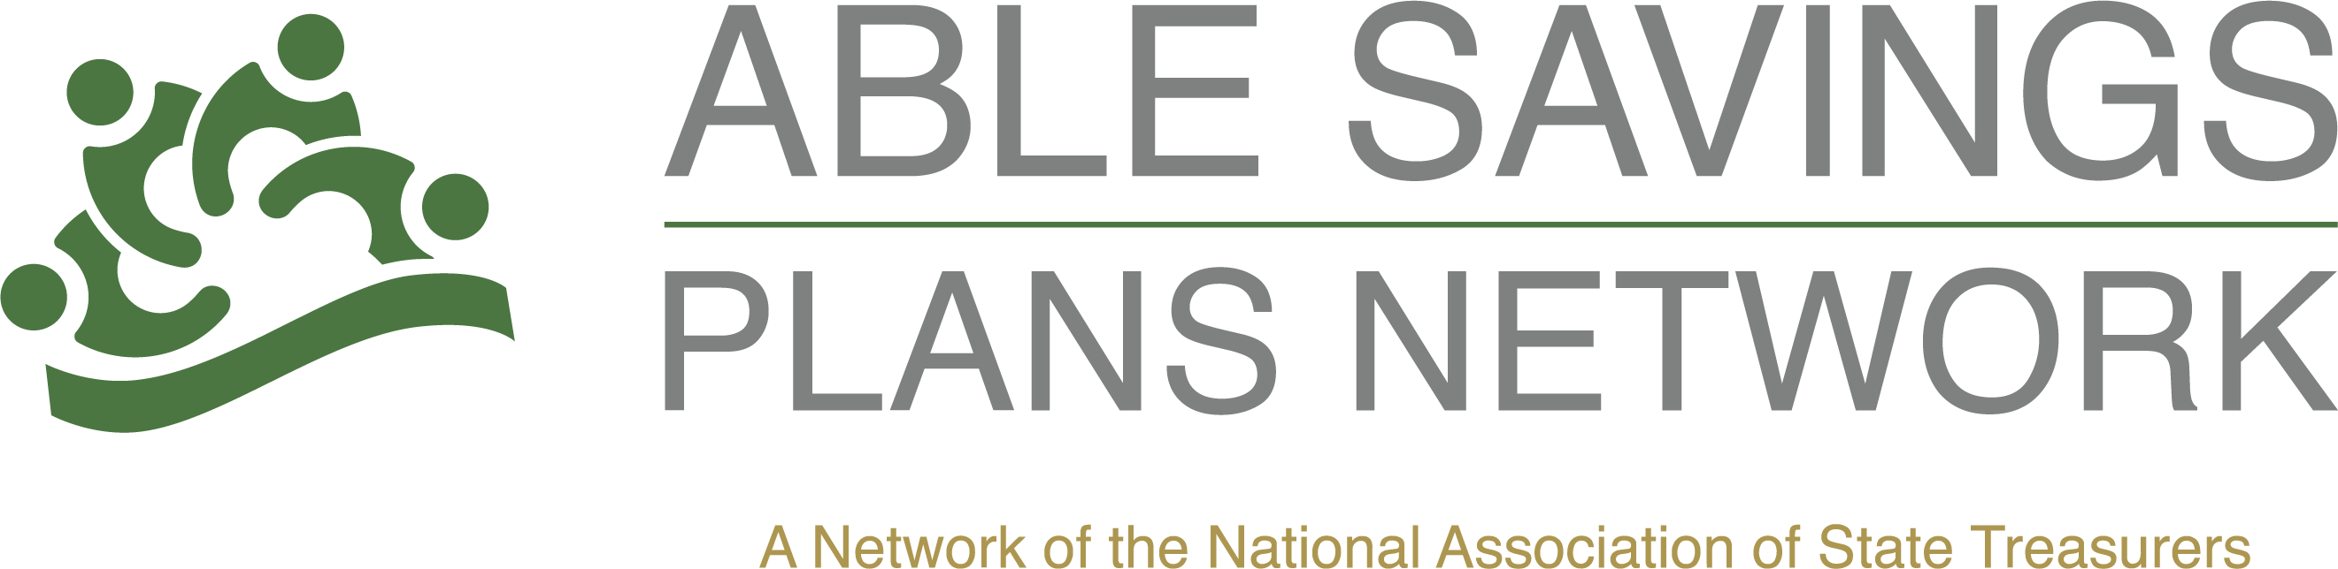

National ABLE Savings Day Communications Tool Kit

Sample Media Pitch
Subject: Local Experts Available for National ABLE Savings Day Stories
Hello,
August 14 is National ABLE Savings Day, a nationwide effort to raise awareness of ABLE savings accounts and the financial independence they provide for individuals living with disabilities.
{STATE PROGRAM} is available to discuss how ABLE accounts help eligible individuals save and invest for qualified disability expenses while protecting eligibility for certain public benefits. We can also provide:
- State-specific enrollment and participation information
- Interviews with program representatives
- Account owner or family success stories (when available)
- Background on recent developments and the growing impact of ABLE programs
National ABLE Savings Day is an opportunity to highlight practical financial tools that are helping individuals with disabilities achieve greater independence, prepare for future expenses, and pursue their personal and professional goals.
If you're planning coverage of disability issues, personal finance, back-to-school resources, or community initiatives, we'd be happy to connect you with a spokesperson.
For interviews or additional information, please contact:
{INSERT INFO}

