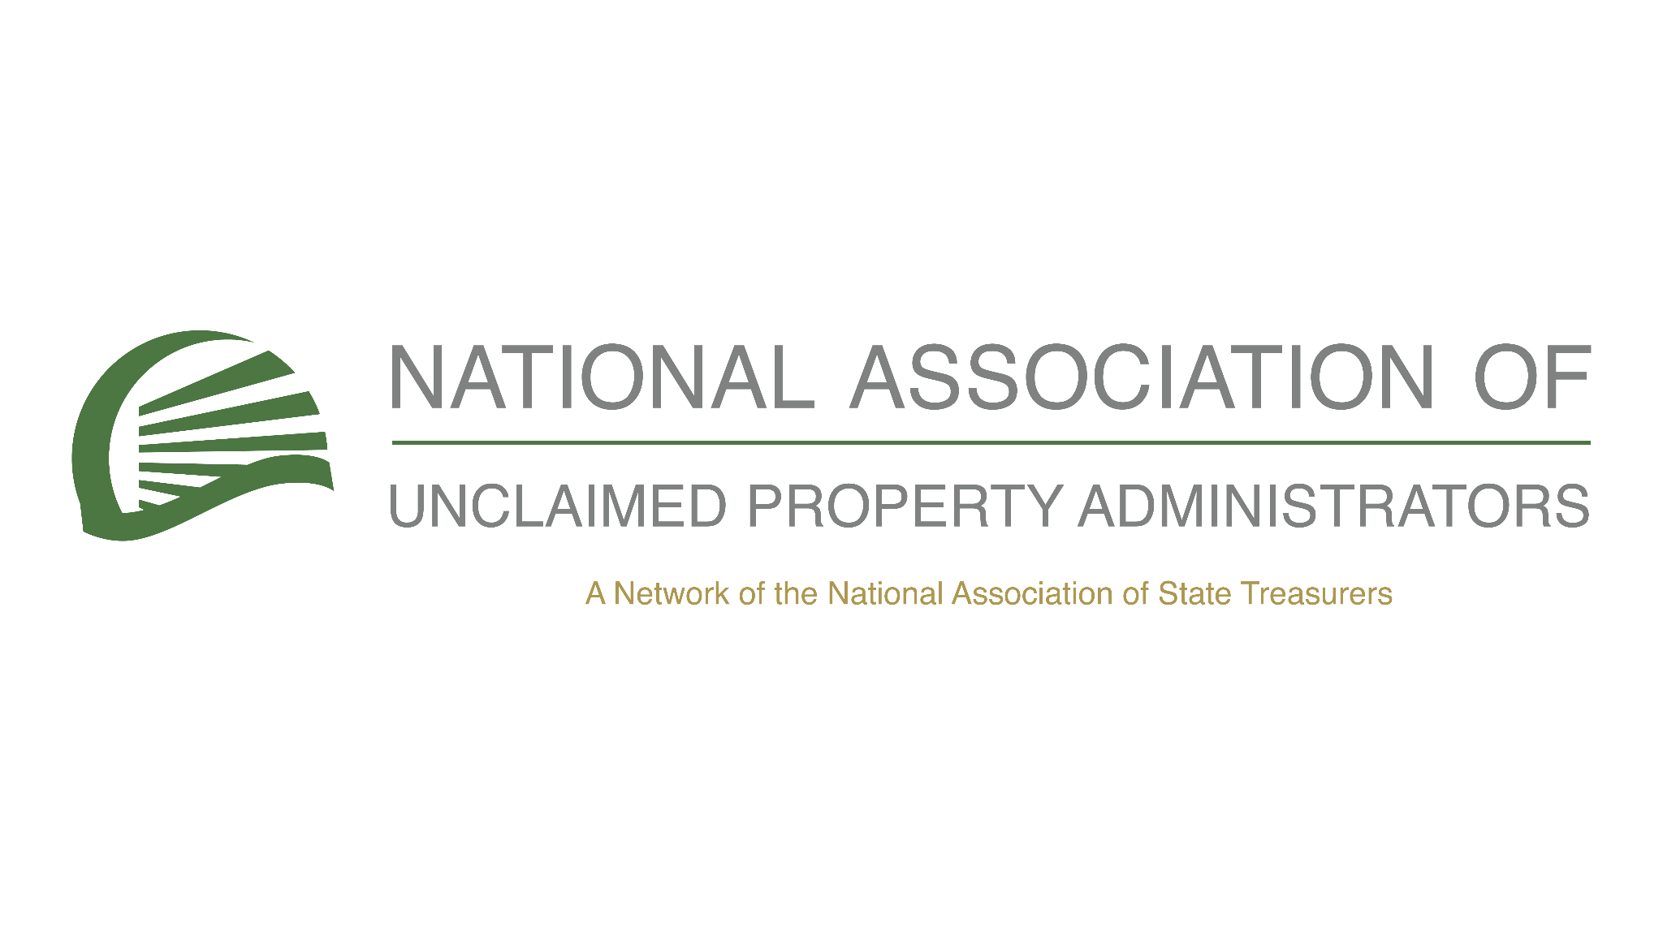
NAUPA 2025 Hispanic Heritage Month Toolkit (English)

Social Media Posts in English

🗓️ Celebrate Hispanic Heritage Month by reclaiming what's yours!
Did you know that billions of dollars in unclaimed property are waiting for rightful owners to claim them? Start your search today at https://missingmoney.com and see if you have something waiting for you.
#HispanicHeritageMonth #ClaimWhatIsYours #UnclaimedProperty

💡 Hispanic Heritage Month is a great time to honor your roots, and what better way than reclaiming any unclaimed property that may belong to you or your business? Over time, unclaimed property like tax refunds, unpaid wages, or old savings accounts can accumulate without you even knowing. Visit https://missingmoney.com to check if there’s something waiting for you!
#ClaimYourProperty #FinancialEmpowerment #HispanicHeritageMonth

It’s time to take action this Hispanic Heritage Month!
Unclaimed property is a reality for millions of Americans, including individuals and businesses. Find out more today—just head over to https://unclaimed.org/ and learn how to discover your unclaimed property!
#FinancialFreedom #HispanicHeritageMonth #UnclaimedFunds

Hispanic Heritage Month is a celebration of community, culture, and heritage—and it’s the perfect time to check if you have any unclaimed property waiting for you!
Whether it’s from an old bank account, uncashed checks, or a forgotten insurance policy, there’s a chance that unclaimed funds belong to you or your family. Search now at https://missingmoney.com!
#HispanicHeritageMonth #FinancialLiteracy #ClaimYourFunds

💼 For business owners, it’s essential to check for any unclaimed property that could belong to your company this Hispanic Heritage Month.
Unclaimed property might include forgotten accounts, insurance policies, or even uncashed checks.Search now at https://missingmoney.com.
#HispanicHeritageMonth #BusinessFinance #UnclaimedProperty

Want to make the most of Hispanic Heritage Month? Start by reclaiming any unclaimed property that could belong to you or your family!
You might be surprised by what’s waiting to be claimed—whether it’s an old paycheck, utility deposit, or insurance refund. Visit https://missingmoney.com to search today!
#HispanicHeritageMonth #ClaimWhatIsYours #UnclaimedFunds

🎉 As we celebrate Hispanic Heritage Month, let’s also think about the future by reclaiming unclaimed property that could benefit you or your family.
It’s simple to check for unclaimed funds—just visit https://unclaimed.org/ to learn more about unclaimed property. Don’t let these funds slip away!
#HispanicHeritageMonth #UnclaimedProperty #FinancialFreedom

Sample Press Release in English

FOR IMMEDIATE RELEASE
[State] Unclaimed Property Office Encourages Residents to Reclaim Funds During Hispanic Heritage Month

[City, State] – [Date] – As part of the celebration of Hispanic Heritage Month, the [State] Unclaimed Property Office is encouraging residents to take advantage of the opportunity to search for unclaimed property that may belong to them, their families, or their businesses. With billions of dollars in unclaimed property available, this is the perfect time to discover funds that may be waiting to be returned.

The [State] Unclaimed Property Office is committed to returning money and assets to their rightful owners. During Hispanic Heritage Month, we recognize the vital contributions of our Latino community and want to ensure that no one is missing out on the financial resources they are entitled to.

QUOTE

How to Search for Unclaimed Property
Residents of [State] can search for unclaimed property for free at https://missingmoney.com, a trusted national database. The search process is quick and easy:
1. Visit https://missingmoney.com
2. Enter your name, business name, or address
3. Review the results and claim any unclaimed property that belongs to you

The [State] Unclaimed Property Office has returned millions of dollars in assets to individuals and businesses over the years. As part of our mission, we are focused on ensuring that these resources are reclaimed and put to good use by their rightful owners.

QUOTE

A Call to Action for Hispanic Heritage Month
In recognition of the rich cultural heritage of the Hispanic community, we want to ensure that everyone has access to the financial resources that are theirs. Whether it’s money from a forgotten savings account, an old utility deposit, or even an unclaimed insurance refund, there’s no better time than during Hispanic Heritage Month to check and reclaim what’s yours.

For more information or to begin your search, visit https://missingmoney.com or contact the [State] Unclaimed Property Office at [Phone Number] or [Email Address].

###

About the [State] Unclaimed Property Office
The [State] Unclaimed Property Office is dedicated to reuniting individuals and businesses with their unclaimed property. From bank accounts to uncashed checks and security deposits, our office works tirelessly to return funds to their rightful owners. We encourage everyone to check for unclaimed property regularly as new items are added to the database regularly.

About Hispanic Heritage Month
Hispanic Heritage Month is celebrated annually from September 15 to October 15, honoring the culture, history, and contributions of the Hispanic community. The month serves as a reminder to recognize the achievements of Hispanic Americans and their vital role in shaping the nation’s past, present, and future.

Same Op-Ed in English

Reclaiming What’s Rightfully Yours: A Call to Action During Hispanic Heritage Month
By [State Treasurer’s Name], [State Treasurer] of [State]

As we celebrate Hispanic Heritage Month, a time when we honor the rich contributions of the Hispanic community to the fabric of our nation, it is also an important moment to reflect on how we can help our communities thrive in tangible ways. One such way is by reclaiming unclaimed property—funds that may be sitting idle, waiting to be returned to their rightful owners. This is particularly relevant for Hispanic families and businesses who may not even know they are entitled to funds that have been forgotten over time.

Every year, millions of dollars in unclaimed property are reported to state treasuries, including mine. These are funds from forgotten accounts, uncashed checks, utility deposits, insurance payouts, and even wage refunds. They belong to you—whether you realize it or not. And yet, many people don’t know that they can claim this property, or they may believe it’s too complicated or time-consuming to track down. The truth is that it’s neither difficult nor costly to search for unclaimed property, and now is the perfect time to do so.

Throughout my tenure as [State Treasurer], I’ve seen firsthand how unclaimed property can be a life-changing resource for individuals and families. From a single mother reconnecting with a life insurance payout that she didn’t know existed, to a small business receiving a check for unclaimed accounts receivable, the impact of claiming these funds can be significant. For many, especially in underserved communities, unclaimed property can provide financial relief, pay down debts, or simply help them build a better future.

During Hispanic Heritage Month, it’s important to highlight the opportunities for the Latino community to benefit from this program. According to our office’s records, many Hispanic families and businesses in [State] may have unclaimed funds waiting to be returned. Whether you have lived here for years or have recently moved to our state, the process of searching for property is simple and free—and it’s a chance to reclaim what is rightfully yours.

You might be surprised by what’s waiting for you. The most common forms of unclaimed property are small, but they add up: old bank accounts, security deposits, uncashed checks, even forgotten tax refunds or wage earnings. It could be money from a utility bill you overpaid, or a life insurance policy you didn’t realize was still active. Over time, funds like these can accumulate and be handed over to the state if they go unclaimed.

But the good news is that, unlike many other forms of lost property, unclaimed funds are not lost forever. As your [State Treasurer], I am committed to ensuring that these funds are returned to the rightful owners, and the best way to do that is by encouraging you to search for unclaimed property now.

It’s easy to get started. All you have to do is visit missingmoney.com, a free and secure national database, to search for unclaimed property using your name, business name, or address. In just a few clicks, you can find out if you have any money waiting for you.

As we celebrate the vibrant history and culture of the Hispanic community this month, I urge you to take a few minutes to check for unclaimed property. It’s a small step that can lead to a big return for you, your family, and your business. Let’s make sure no one misses out on the funds they are rightfully entitled to.

Together, we can make a real difference. Celebrate your heritage, and reclaim what’s yours.

[State Treasurer’s Name]
[State Treasurer] of [State]

