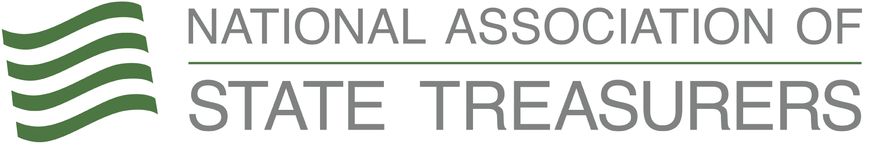

Financial Literacy Month Tool Kit
To: NAST Members
From: Catherine Seat, Communications Director

Introduction
In this toolkit you will find several ways to promote Financial Literacy month in your state. We have organized graphics, created sample tweets, and drafted both an op-ed for your local paper as well as a press release. Please use any/all of the resources!
If you have any questions or would like some additional support, please reach out to Catherine at Catherine@statetreasurers.org.
Graphics
https://nast.org/wp-content/uploads/financialwellness/speakers/infographic.pdf
https://nast.org/wp-content/uploads/financialwellness/speakers/worksheet.pdf

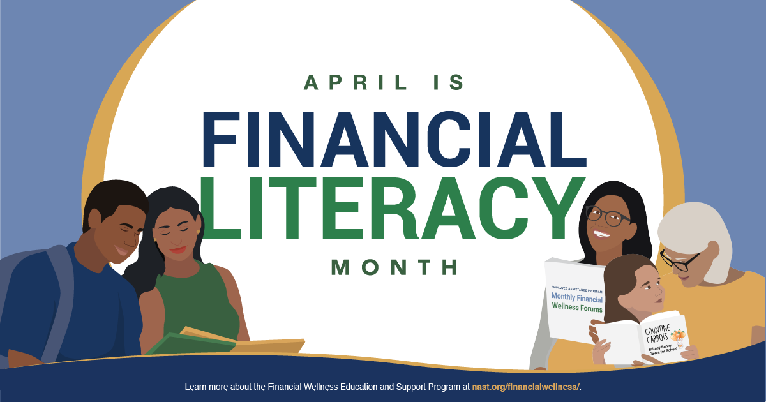
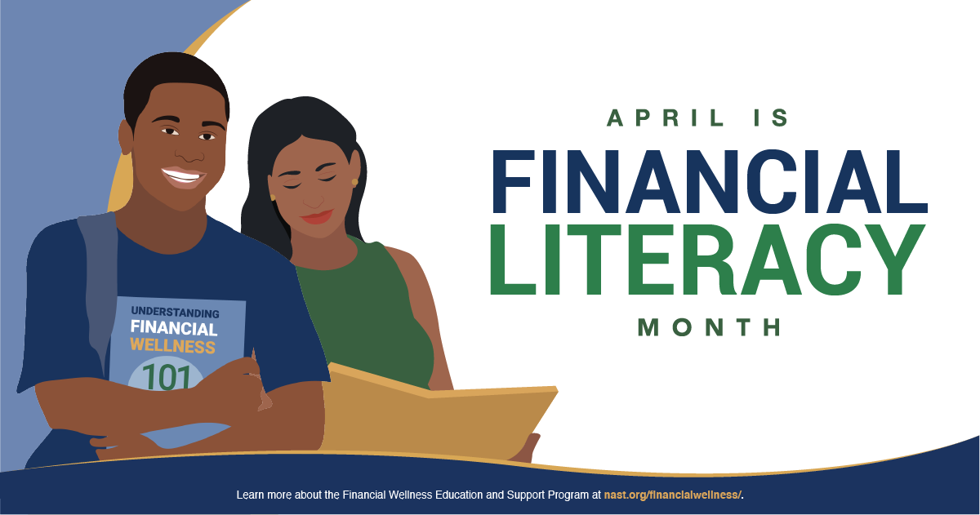

Social Media Posts
https://nast.org/wp-content/uploads/financialwellness/toolkit/social.pdf
Hashtags: #FinancialEducation #NASTSaves #StateTreasurers
Tags: @StateTreasurers @529forCollege
Did 2020 leave you financially stressed? You are not alone! Learn more about how to take charge of your finances with this free financial wellness program: https://bit.ly/3t3y3cA #FinancialEducation #NASTSaves
Americans owe more than $1.64 trillion in students loan debt. Are you one of them? @529forCollege accounts help Americans invest for education expenses. Let’s plan and save during Financial Education Month instead of borrow and pay later! #NASTSaves
Does budgeting seem scary? Don’t want to know where your money actually goes every month? Check out this easy-to-use fill-in-the-blank worksheet to gauge your financial wellness: https://bit.ly/3rBY5Dn Take charge today! #FinancialEducation
April is #FinancialLiteracyMonth. Tell us what you are doing to improve your financial wellness this month in the comments! Need ideas? Check out these resources: https://bit.ly/3rBYOEB #NASTSaves
Want to learn more about financial education opportunities throughout the country? Click on your state and see how you can get involved! https://nast.org/financialwellness/census/ #NASTSaves #StateTreasurers

Sample Op-Ed
https://nast.org/wp-content/uploads/financialwellness/toolkit/op-ed.pdf
April showers bring May flowers, right? April is a month of renewal and rebirth as we shake off the cold of winter, watch flowers bloom, and hope for the warmth of summer. As we do our spring cleaning, let us also consider a review of our financial wellness in the spirit of renewal this April.
In many circles, April is celebrated as Financial Literacy Month. A time to encourage Americans to learn a new financial tool, save a little extra money, and plan for our financial future. That looks different to every person.
According to PwC’s annual Employee Financial Wellness Survey, financial or money challenges accounts for 54% of the stress their employees face every day. As an employer myself, I want to provide resources to meet the needs of my employees and what causes them stress.
I am a proud member of the National Association of State Treasurers (NAST). We have been working diligently to provide financial education resources to the constituents of {STATE}. Recently, NAST’s Foundation, along with the Center for State and Local Government Excellence and the International Public Management Association for Human Resources, funded by Wells Fargo developed the Financial Wellness Education and Support Program. This program works specifically with government employees to give them financial education tools for success however, these resources are valuable to everyone! I urge {Constituent Descriptor like “Hoosiers”} XX to take advantage of these free financial education tools.
2020 tested us in various ways, but I think it is important to take this month of renewal and rebirth to set ourselves up for success in 2021 – and your financial health is a huge part of that. Many Americans faced financial hardships last year and it will take time to bounce back. I challenge you to learn a new tool, save extra money, and plan for 2022 this month!
{INSERT STATE SPECIFIC STORY OF FINANCIAL EDUCATION/INDEPENDENCE OR PROGRAM}
Resources and tools are readily available to take your financial knowledge to the next level. In XX, we have {INSERT RESOURCES/HELPFUL WEBSITES}. During this spring season, plant seeds now that will grow and produce lasting change for you and your family.

Sample Press Release
April XX, 2021 (City, State) – April is Financial Literacy Month. A dedicated time to reflect on the state of financial education in local communities and across the nation. Treasurer XX is dedicated to the financial wellness of XX.
With 2020 in the rearview mirror, it is more important than ever to evaluate the financial aptitude of the country. According to the Economic Policy Institute, in the early weeks of the coronavirus crisis, women filed nearly 59% of unemployment claims, despite being half of the labor force. For those who have served our country, more than 3 in 4 veterans have some financial worries, most commonly a lack of savings to cover retirement and other needs according to the National Foundation for Credit Counseling. State Treasurers are well appointed in their community to address this need.
{Quote from Treasurer XX}
The National Association of State Treasurers (NAST) have provided tools for the continued financial education of government employees. Brought together by this shared mission, the Center for State and Local Government Excellence, the International Public Management Association for Human Resources and the NAST Foundation, funded by Wells Fargo developed the Financial Wellness Education and Support Program. This program published a toolkit for speakers and conferences on the topic as well as booklet walking through several stages in a person’s financial journey.
{Insert Local Financial Education Program}
For more information on the Financial Wellness Educations and Support Program, email XX at XX. To contact the Office of XX State Treasurer, please call XX or email XX.
###

Resources
State’s Financial Education Program Census: https://nast.org/wp-content/uploads/financialwellness/census/2020nastfinancialwellnesscensus-allstates.pdf

